**Git Workflow**

* Note: This is a partial workflow and we will be learning complete git in 2 weeks from now
* Git Remote Repositories are hosted by GitHub/GitLab/Azure Source Repos etc
* If we don’t have the Code in local system, then we clone the code to create local repo
* Once we have local repo, to get latest changes we use pull
* We add the changes to the staging area using add and commit the changes to local repo using commit and sync the changes from local to remote repo using push command  
  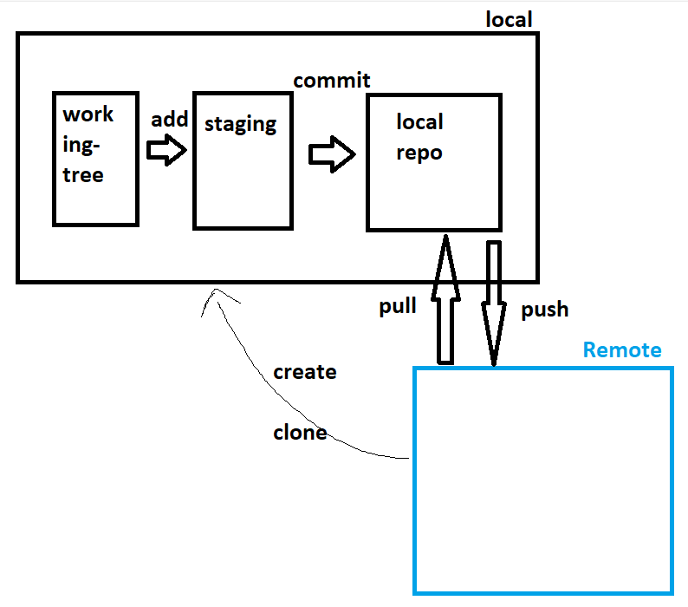

**Create a Git Repository in GitHub**

* Create a new repository after login into github  
  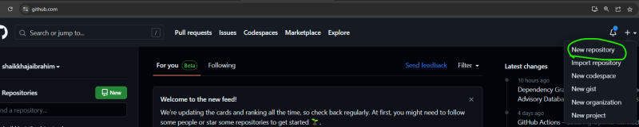  
  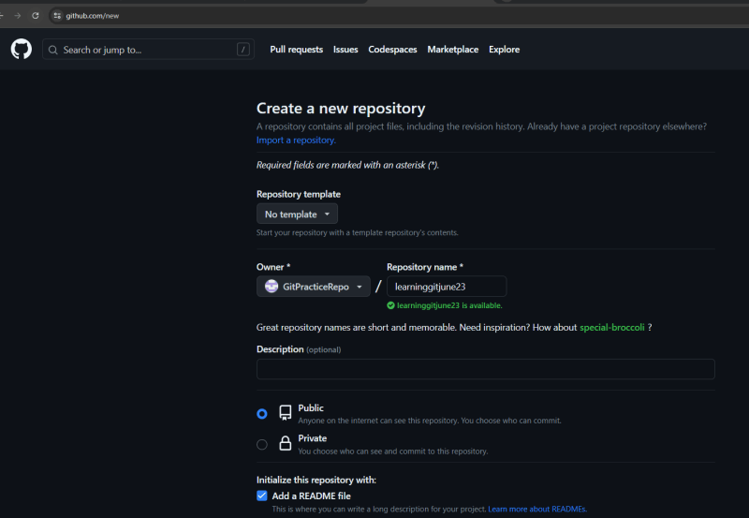  
  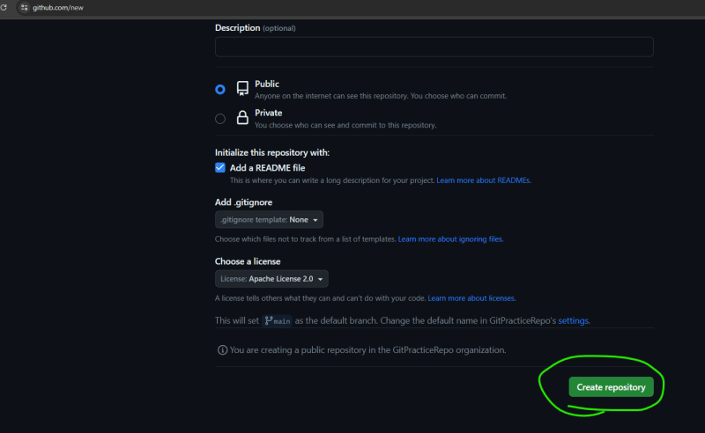  
  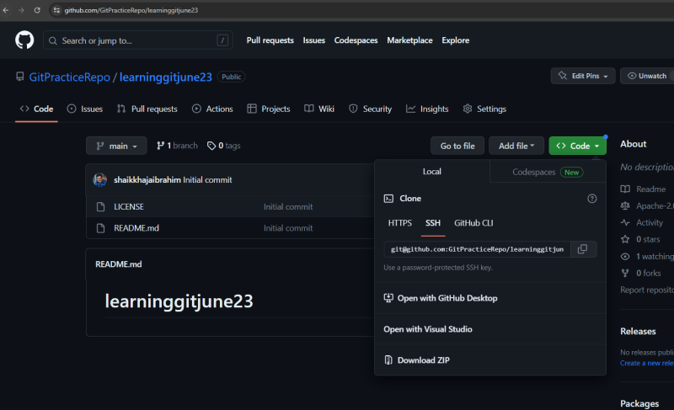

**Cloning the code into local system**

* Identify a folder for local repo C:\temp\gitpractices
* Now clone using a command git clone <git-url>  
  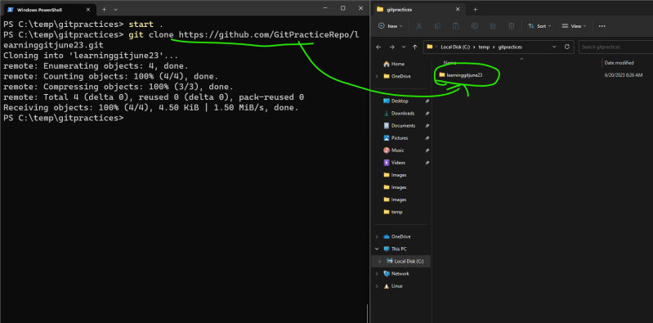
* lets look into what are the contents  
  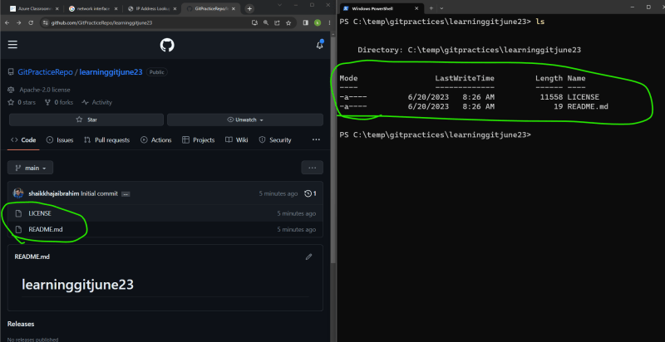

**Make changes locally and push to the Remote**

* Add the changes in working tree and then add to staging area.
* Commit the changes and push to the remote  
  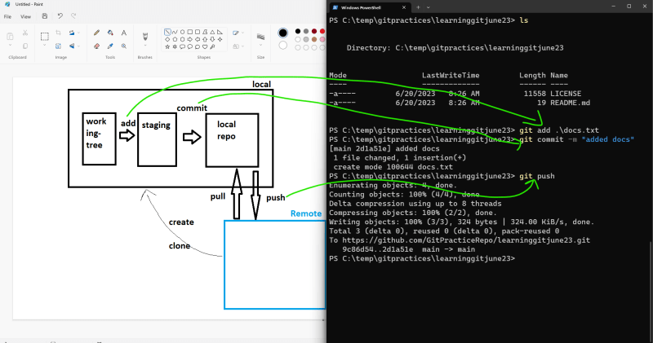  
  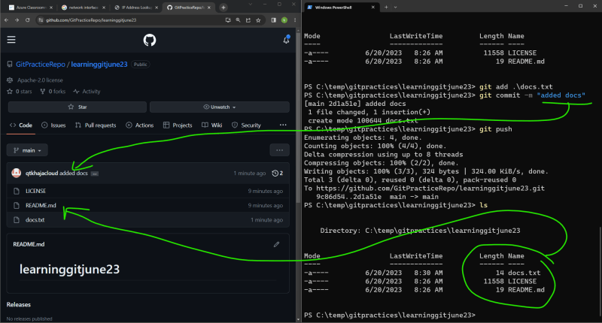
* Adding multiple changes
  + Files already in repo will have status of modified or deleted or renamed

Files newly created will have status of untracked  
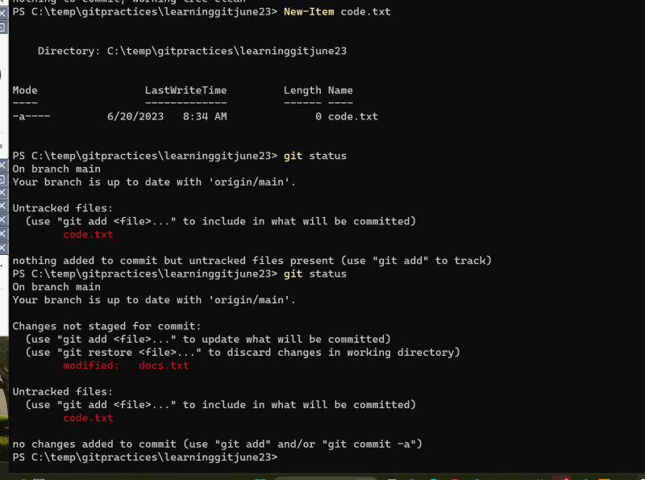

* we can add multiple changes at once to the staging area
* When we want to move the changes from staging area to local repo, it needs message, author username and email address  
  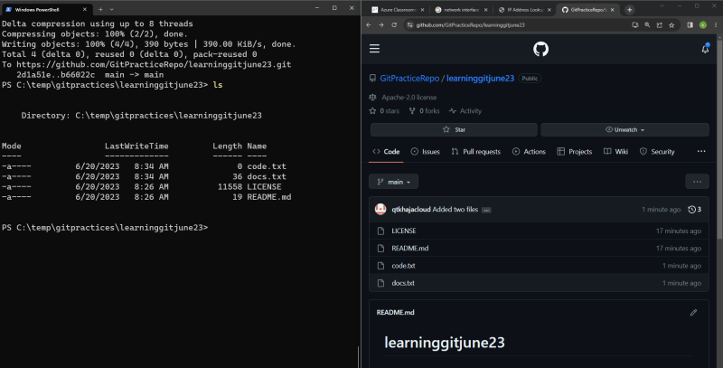

**Get changes from remote into local when repo already exists**

* Use pull  
  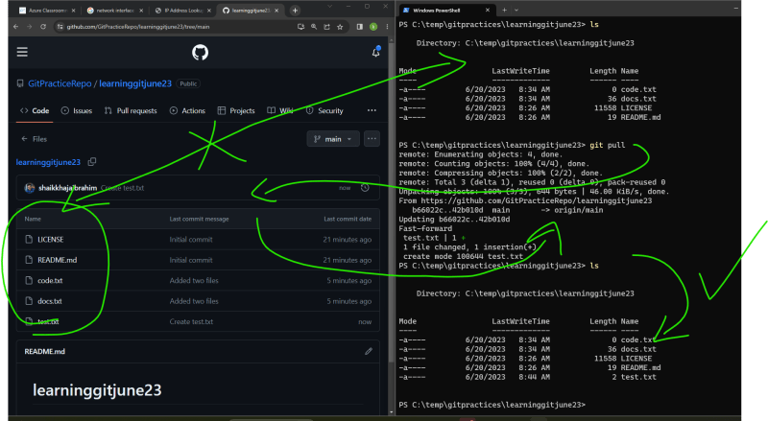
* Git ways of working in non-tech way  
  